# ProjectDesignPhase-I Solution Architecture

|  |  |
| --- | --- |
| Date | 28October2023 |
| TeamID | **NM2023TMID11864** |
| ProjectName | **Transparent Toll-Free Data Management** |
| MaximumMarks | 4Marks |

**SolutionArchitecture:**

Solutionarchitectureisacomplexprocess–withmanysub-processes–thatbridges the gap between business problems and technology solutions. Its goals are to:

* Findthebesttechsolutiontosolveexistingbusinessproblems.
* Describethestructure,characteristics,behavior,andotheraspectsofthe software to project stakeholders.
* Definefeatures,developmentphases,andsolutionrequirements.
* Providespecificationsaccordingtowhichthesolutionisdefined,managed, and delivered.

# SolutionArchitectureDiagram:

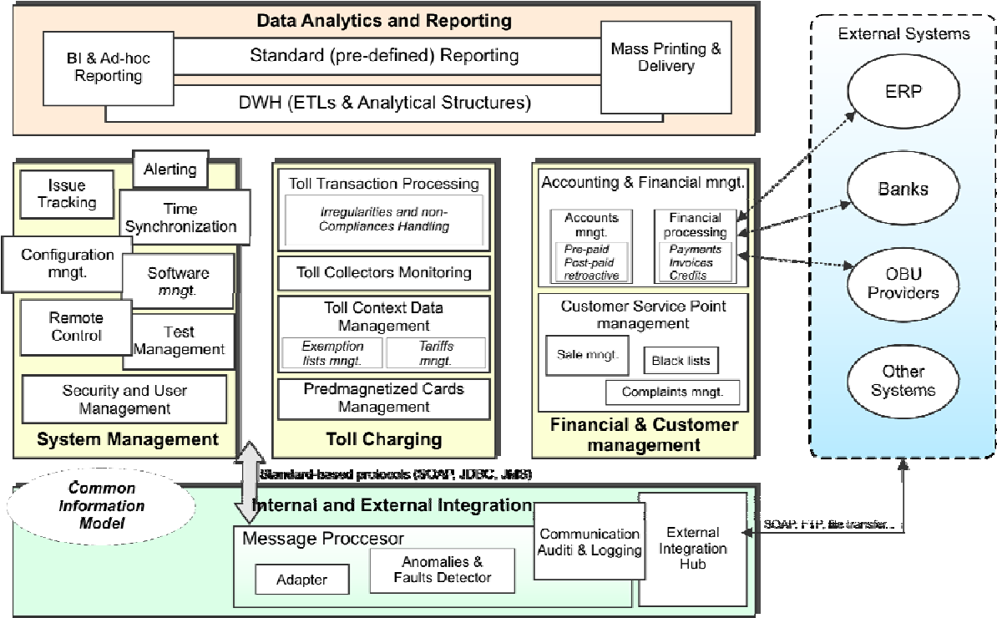

**Prerequisite**

1downloadnode.js:[Node.js](https://nodejs.org/en)

**2**downloadvscode:[**Li4nk**](https://code.visualstudio.com/download)

3downloadmetamask:<https://metamask.io/>

# Stepstocompletetheproject Step 1:-

1. OpentheZipfileanddownloadthezipfile. Extract all zip files

# Step 2:

1. Openvscodeinthelefttop selectopenfolder.Selectextractedfileandopen .
2. Selecttheprojectname.sol fileandcopythe code.
3. Opentheremixideplatformandcreateanewfilebygivingthenameof projectname.sol and paste the code which you copied from vs code.
4. Clickonsoliditycompilerandclickcompilethe projectname.sol
5. Deploythesmart contractbyclickingonthedeployandrun transaction.
6. selectinjectedprovider-MetaMask.Inenvironment
7. Clickondeploy.AutomaticallyMetaMaskwillopenandgiveconfirmation.Youwillget a pop up click on ok.
8. IntheDeployedcontractyoucanseeoneaddresscopythe address.
9. Openvscodeandsearchfortheconnector.js.Incontract.jsyoucanpastethe address at the bottom of the code. In export const address.
10. Savethecode.

# Step 3:

openfileexplorer

1. Opentheextractedfileandclickonthe folder.
2. Opensrc,andsearchforutiles.
3. Youcanseethefrontendfiles.Selectallthethingsatthetopinthesearchbarby clicking alt+ A. Search for cmd
4. Opencmdentercommands npminstall

npmbootstrap npmstart

1. It will install all the packages and after completing it will open {LOCALHOST IP ADDRESS}copytheaddressandopenittochromesoyoucanseethefrontendofyour project